2017 NEC: Article 210.71
2022 CEC: Article 210.65
2020 NEC: Article 210.65
2023 NEC: Article 210.65

Meeting / Conference rooms:
The NEC requires that meeting rooms 1,000 square feet or less, in other than dwelling units, now have a minimum number of receptacles. Note that if the room / space has a movable partition, then the square footage for the below requirements shall be determined with the partition in the position that results in the smallest size meeting / conference room.

The first requirement (2017 Article 210.71(B)(1) / 2020 - 2023 Article 210.65(B)(1)): The number of receptacles in the space(s) must be determined in the same manner as the receptacles in a bedroom. The minimum number required shall be determined by Article 210.52(A)(1) thru (A)(4). See example below:
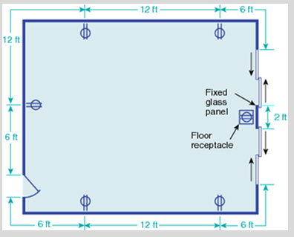

The second requirement (2017 Article 210.71(B)(2) / 2020 - 2023 Article 210.65(B)(2)): If the meeting / conference room is at least 12’ in any direction and is 215 square feet or greater, then a floor receptacle will be required and must be located no less than 6’ from any fixed wall. In addition to this, a floor receptacle is required for each additional 215 square feet.
Note: If the meeting / conference space is less than 12’ in any direction, then this rule does not apply. Example: A conference room that is 10’ wide x 25’ long would not require a floor receptacle. Although it is greater than 215 square feet, it’s less than 12’ wide. Both requirements must be met for this rule to apply.
It’s important to note that both these rules only apply to meeting / conference spaces that are 1,000 square feet or less. If the space is greater than 1,000 square feet, then both these rules do not apply.

